Explore weather trends

Project 1

Britta Ente

Step 1

Extract the data from the database

Program: sql

First I had to find the city I live in called Hamburg

select city

from city_list

where city ='Hamburg';

then I had to find the temperature for my city

select city, avg_temp, year

from city_data

where avg_temp >0 AND city ='Hamburg'

at the end I had to find the global dates

select avg_temp, year

from global_data;

second step

download the csv file and open it in excel.

I started in the year 1750, as before this date we got no global dates. I used the moving average for a period of ten years. So I took the average of 10 years for both Hamburg and global. Then I copied this formula until I reached the year 2013.

Afterwards I stored the excel file and opened it in tableau. Kindly see my line chart

https://public.tableau.com/profile/britta.ente#!/vizhome/exploreweathertrends_0/Sheet2?publish=yes

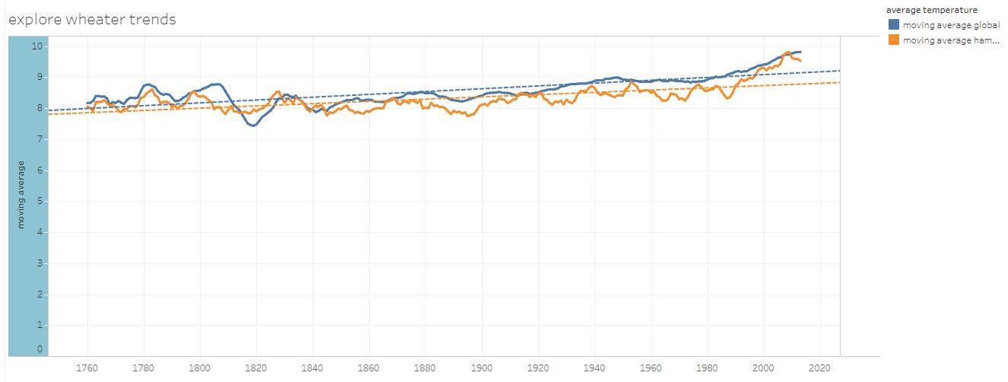

The advantage of tableau is that you can click on each year, each trend line and each temperature for each Hamburg and global. This makes it a lot easier to get some insights of the data.

third step

1. The average temperature in Hamburg is less than global. Hamburg is a city in the north of Germany, so this makes sense.
2. Both global and Hamburg got the clear trend to become warmer and warmer each year. The trend lines shows this also very clearly. By 2100, an average global temperature increase of between 1.8 (with a fluctuation range of 1.1-2.9) and 4.0 (with a fluctuation range of 2.4-6.4) degrees Celsius is assumed. This climate change is caused by the greenhouse effect.
3. The last 20 years both figures shows a remarkable increase of the temperature. In the year 1988 the moving average temperature for Hamburg was 8,354 and in the year 2009 we got already 9,809. I would estimate that this effect is not only caused by the climate change but also by the fact that the cities heat up extremely in summer. The living space in Hamburg has been constantly expanded and compressed due to the large influx of people. All the large concrete surfaces heat up the city very much. In the countryside it is usually about 5 degrees cooler.
4. The curve with the data from the global temperatures is subject to minor fluctuations than the data from the city of Hamburg. This makes sense because the global data have processed very many data sets, so that fluctuations from individual data are not so important.
5. Interesting is the global temperature decline in 1816-1822. The year without summer is described as the unusually cold year 1816, especially in the north-east of America and in western and southern Europe. In the United States it was nicknamed "Eighteen hundred and froze to death", and also in Germany it became infamous as the year of misery "Eighteen hundred froze". Today, the eruption of the Indonesian volcano Tambora in April 1815 is regarded as the main cause.